Reset Epson L130 printer with Epson adjustment program

Download WIC Reset Utility Tool – **Epson L130 resetter** to **reset Epson L130** printer waste ink counter overflow and reset flashing lights problem condition on my Epson L130 printer with **Epson adjustment program**.

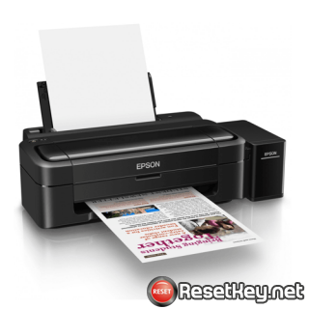

If Epson L130 printer shows error message “**The Printer’s Ink Pads at the end of Their service life**” and Epson L130 printer has red light blinking problem: You need to download and reset your Epson L130 printer Waste Ink Pads Counter with Epson L130 Resetter ([How to reset](https://resetkey.net/reset-epson-l130-printer-with-epson-adjustment-program.html#resetprinter))

Epson L130 printer Waste Ink Counter error and how to repair that

– Does Epson L130 printer stop to printing and say parts inside your Epson printer are at the end of their life?

– Does it say Epson L130 ink pads need changing?

– Have you got an e-letter in the display and flashing red lights?

– Are you being told to take your Epson L130 printer to an Epson service center?

Epson L130 printer and every Epson Printers have an internal Waste Ink Pads to collect the wasted ink during the process of cleaning and printing. When this ink pads reaches its limitation, Epson L130 will send you Warning alert and refuse to function.

How to know Epson L130 printer waste ink pad counter overflow

Waste Ink Pads are a number of sponge pads inside your Epson L130 printer which is responsible for absorbing, receiving, accommodating waste ink during the printing, cleaning the printhead. Once these Waste Ink Pads is overflow, the Epson L130 printer will stop printing immediately.

**1. If your Epson L130 printer has LCD screen**, the LCD screen will give an problem: “The Printer’s Ink Pads are at the end of Their service life. Please contact Epson Support” or “The Printer’s Ink Pad is at the end of It service life. Please contact Epson Support”.

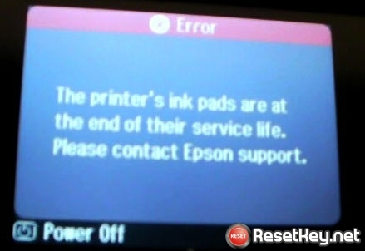

2. The printer’s **red light blinking** error



3. **Computer show problem message** “A printer’s ink pad is at the end of its service life. Please contact Epson Support”

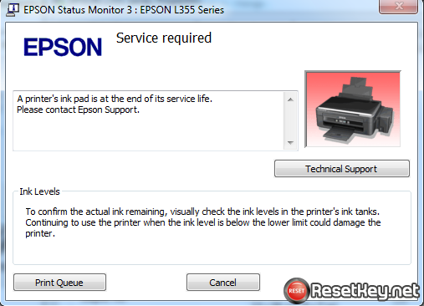

4. **Check Waste Ink Counter by WIC Reset**: Run Wic Reset Utility tool, click “**Read Waste Counters**” button, full counter is 100%. Epson L130 Waste ink Counter overflow means that counters values are more than 100%.

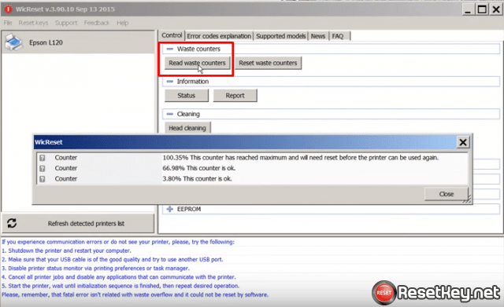

WIC Rest Utility Tool can fix your printer

**Step 1: Free Download WIC Reset Utility Tools**

We have both version for Windows and Mac OS X. You can download WIC Reset Utility in [[**Download Page**](https://resetkey.net/download)] or by direct link below:

[*[****Download WICReset Utility for Windows****]*](https://resetkey.net/tools/wicreset.zip)

[*[****Download iWIC Utility for MAC OS X****]*](https://resetkey.net/tools/iWIC.zip)

[=> Mirror download here](https://resetkey.net/download)

**Step 2: Get WIC Reset Key**

The One Time RESET KEY is required for RESET FUNCTION when you are using the WIC Reset utility to reset Epson L130 printer.

[Wic Reset Key](https://resetkey.net/buy) for use with **Epson Adjustment Program** (WICReset on Windows, iWIC on Mac) is available for purchase on ResetKey.net

[Get Epson L130 Waste Ink Counter reset key](https://resetkey.net/buy)

**Step 3: How you can reset Epson L130 computer printer with Epson adjustment program**

Reset Epson L130 printer by **Epson adjustment program** is very simple. You can easy reset your Epson L130 printer by Yourself

**This is quick guide:**

**Before reset Epson L130 printer**:

+ Disable all USB connection and printer

+ Close all printing job

+ Connect Epson L130 printer and your computer by USB cable only. (You can’t reset Epson L130 with WIFI and also LAN network)

+ Some printer you have to [Disable the Epson Status Monitor](https://resetkey.net/disable-the-epson-status-monitor)

+ Connect your computer to the internet.

+ Download, setup then run WIC Reset Utility tool

**Reset Epson L130 printer:**

+ Select Epson L130 printer in the right sidebar of WIC Reset Tool:

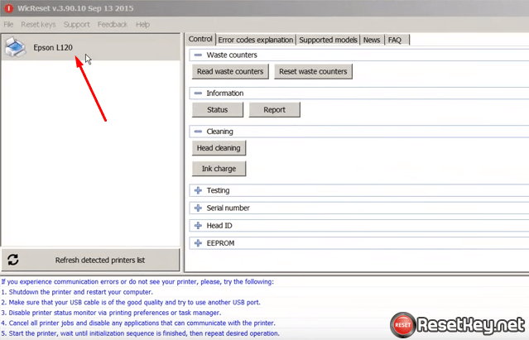

+ Click “**Reset Waste Counters**” button:

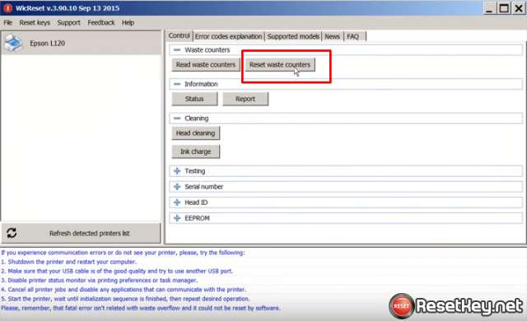

+ Enter Epson L130 Wic Reset Key you have received in email:

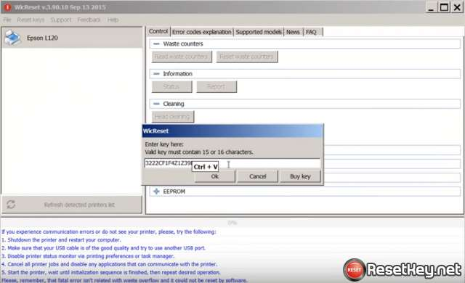

+ Wait a second, when WIC Reset Tool says you turn printer OFF, turn OFF Epson L130 printer, after turn OFF Epson printer, you will receive message:”Congratulations, Your printer waste counter(s) have now been reset”.

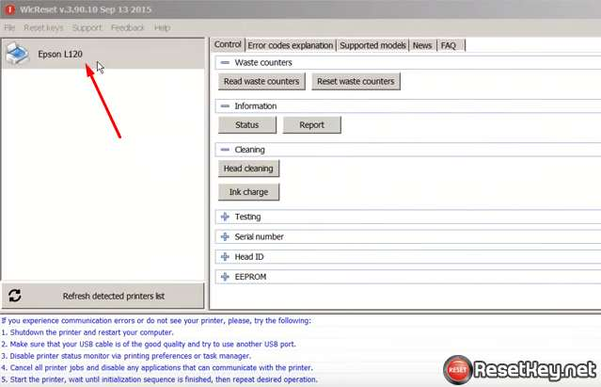

**You can read full guide here:**

+ [Watch video how to reset your Epson L130 printer with WicReset Tools here](https://www.youtube.com/watch?v=bLOLenDMvx8&list=PLfI9HFNF3KErGj_YourxVZjY3GYqoHA3H&index=2)

+ [Read how to reset Epson L130 printer with WicReset Tool by here](https://resetkey.net/howtoreset)

If you don’t know what is Epson L130 printer’s Waste Ink Pad – [Read here](https://resetkey.net/the-importance-of-waste-ink-pad.html)

If you have any question, please [[Click here](https://resetkey.net/faq)] to visit **F.A.Q** page or you can [contact us](https://resetkey.net/contact)

Have a nice day!